**PSG College of Technology, Coimbatore- 4**

**Department of Applied Mathematics and Computational Sciences**

**I Sem MSc CS - 20XC17 C Programming Lab**

**Preamble Problem Sheet -1**

1. Write a program that asks the user to enter the initial velocity, acceleration of an object and the time that has elapsed, places them in the variables u, a, and t, and prints the final velocity, v, and distance traversed, s, using the following equations.

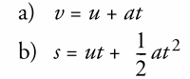

1. Write a program to input a length expressed in feet and inches and output the same length expressed in centimeters. [Note: 1 inch =2.54 cm, 1 feet = 30.48 cm]
2. Write a program that reads a Celsius degree in a double value from the console, then converts it to Fahrenheit and displays the result. The formula for the conversion is as follows: *fahrenheit = (9 / 5) * celsius + 32*
3. Write a program that calculates mileage reimbursement for a salesperson at a rate of Rs. 0.35 per mile. Your program should interact with the user in the following manner.



1. Given an airplane’s acceleration *a* and take-off speed *v,* you can compute the minimum runway length needed for an airplane to take off using the following formula:



Write a program that prompts the user to enter *v* in meters/second (m/s) and the acceleration *a* in meters/second squared (m/s2), and displays the minimum runway length.

1. Write a program that converts and prints a user-supplied measurement in inches into
2. foot (12 inches)
3. yard (36 inches)
4. centimeter (2.54/inch)
5. meter (39.37inches).
6. An electronics company sells circuit boards at a 40 percent profit. Write a program that calculates the selling price of a circuit board that costs them Rs.1200.67 to produce. Display the result on the screen.
7. Suppose you save Rs. 100 *each* month into a savings account with the annual interest rate 5%. Thus, the monthly interest rate is 0.05/12 = 0.00417. After the first month, the value in the account becomes

100 * (1 + 0.00417) = 100.417

After the second month, the value in the account becomes

(100 + 100.417) * (1 + 0.00417) = 201.252

After the third month, the value in the account becomes

(100 + 201.252) * (1 + 0.00417) = 302.507

and so on.

Write a program that prompts the user to enter a monthly saving amount and displays the account value after the sixth month.

1. Write a program that computes the total sales tax on a Rs. 1000 purchase. Assume the state sales tax is 4 percent and the county sales tax is 2 percent. Display the purchase price, state tax, county tax, and total tax amounts on the screen.
2. Items in a store are often sold at a discount from the list price, and the customer must pay sales tax on the total amount of the purchase. Write a program to input the list price of an item, the percentage discount, the number of items ordered, and the sales tax rate (in percentage). The program should print the cost of the order before the discount is applied, the amount of the discount, the discounted cost, the amount of sales tax, and the total amount that the customer must pay.
3. The batting average of a baseball player is calculated by subtracting the number of times the player walked from the number of times at bat and dividing the difference into the number of hits the player made. The result is traditionally expressed with three decimal places, as in 0.297. Write a program to obtain the necessary data from the user and compute the batting average.
4. Write a program that computes the tax and tip on a restaurant bill for a patron with a Rs. 44.50 meal charge. The tax should be 6.75 percent of the meal cost. The tip should be 15 percent of the total after adding the tax. Display the meal cost, tax amount, tip amount, and total bill on the screen.
5. Write a program that asks for your height in feet and inches and your weight in pounds. Report your BMI (Body Mass Index). To calculate the BMI, first convert your height in feet and inches to height in only inches. Convert your height in inches to your height in meters by multiplying by 0.0254. Then, convert your weight in pounds into your mass in kilograms by dividing by 2.2. BMI = mass in kilograms / height in meters 2
6. Write a program to calculate the property tax. Property tax is calculated on 92% of the assessed value of the property. For example, if the assessed value is Rs 200,000, the property tax is on Rs 184,000. Assume the property tax rate is Rs 1.05 for each Rs 100 of the assessed value. Your program should prompt the user to enter the assessed value of the property. Store the output in a file in the following format. (Here is a sample output.)

Assessed Value 200000.00

Taxable Amount 184000.00

Tax Rate for each Rs 100.00 1.05

Property Tax 1932.00

Format your output to have decimal places. (Note that the left column is left-justified and the right column is right-justified.)

1. Write a program to calculate the slope of a line, given the data for coordinates of the end points of the line. Input four real numbers representing coordinates x1, y1 and x2, y2. The slope of a line is given by the formula: $m=\frac{y_{2}-y_{1}}{x_{2}-x_{1}}$.

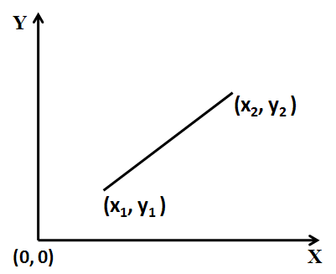

1. Write a program that prompts the user to enter the three points (x1, y1), (x2, y2), and (x3, y3) of a triangle and displays its area. The formula for computing the area of a triangle is

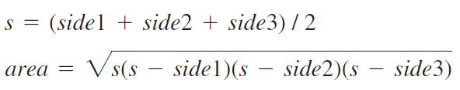

Here is a sample run:

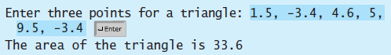

1. Compute the effective resistance and voltage of an electrical circuit containing three resistances connected in parallel, with the current and resistance as input data. Input three positive values for resistances R1, R2, and R3, and a positive value for current (in ohms) I and computes the resistance as Resistance R=1/((1/R1)+ (1/R2)+ (1/R3)), Voltage V= I * R.
2. Write a program to find the simple interest (SI) and compound interest (CI) by getting principle amount, rate of interest and years as input.

[ SI=(P*N*R)/100.0, CI=pow((P*(1+R)/100.0),N) ]

1. Design and implement an interactive program that reads an amount in rupees as an integer and determines and prints the minimum number of bills of Rs. 50, Rs. 20, Rs. 10, Rs. 5, and Rs. 1 denominations in it. For example, if the amount is Rs. 179, your program should print that it consists of three 50, one 20, zero 10, one 5, and four 1 bills.
2. A car with a 20 gallon gas tank averages 21.5 miles per gallon when driven in town and 26.8 miles per gallon when driven on the highway. Write a program that calculates and displays the distance the car can travel on one tank of gas when driven in town and when driven on the highway.